Climate Change is Driving Shifts in Seasonal Violence Patterns
David Buil-Gil¹, Thiago R. Oliveira¹ and Diego J. Maldonado-Guzmán²
¹ Department of Criminology, University of Manchester, Manchester, UK
² Department of Public Law, University of Malaga, Malaga, Spain

Acknowledgements
The authors would like to thank colleagues in the Reading Sessions for Quantitative Criminology at the University of Manchester for comments that helped improve the manuscript.

Abstract
Seasonal patterns in violent crime are among the most robust findings in criminology, typically linked to weather conditions and routine activities. Yet little is known about how climate change, particularly shifting rainfall patterns associated with global warming, may be reshaping these well-established seasonal dynamics. This study examines whether recent changes in rainy and dry periods in the Central American and Caribbean region are influencing the seasonality of violent crime. We analyze data on violent offences from three case studies: Colombia (2003-2024), Mexico (1997-2024), and Gainesville, Florida (2011-2024). Data are modelled using a series of fixed-effects panel regressions with fixed effects for year and month, and, where possible, random slopes for geographic areas. Each case study offers a distinct analytical perspective: Colombia provides fine-grained spatial and temporal detail, Mexico extends temporal coverage to nearly three decades, and Gainesville introduces a Global North comparison. Across all three contexts, we observe a displacement of traditional seasonal crime cycles that correspond with shifts in rainfall seasonality. Multiple modelling approaches yield consistent results. The findings suggest that climate change may be altering not only environmental conditions but also the temporal rhythms of crime, calling for renewed attention to the climate-crime nexus in theory and policy.

1 Introduction
Seasonal patterns in violent crime are among the most replicated findings in criminology. Since Quetelet (1842) first documented winter peaks in property crime and summer peaks in violence in 19th-century France, research has repeatedly shown that crime follows predictable seasonal cycles (Andresen & Malleson, 2013; Baumer & Wright, 1996; Cohn, 1990; Hipp et al., 2004; McDowall et al., 2012). Across decades and theoretical traditions—from routine activity theory (Cohen & Felson, 1979) to affective aggression models (Anderson et al., 1995; Baron & Bell, 1976)—violent crime is understood to rise and fall with regular shifts in temperature, daylight, and precipitation. Yet this well-established regularity relies on an implicit assumption: that the seasons themselves are stable. In many parts of the world, this assumption no longer holds, as climate change associated with global warming alters the timing, intensity, and duration of seasonal patterns.
While recent changes in temperature and precipitation patterns have been documented globally (Dore, 2005; Reyer et al., 2017), the Caribbean and broader Central American region offer a paradigmatic example. Rather than four distinct seasons, the region is shaped by a complex hydroclimate governed by interacting atmospheric systems, producing what has been described as a bimodal rainfall regime, with a rainy season influenced by tropical cyclones alternating with a dry season (Almazroui et al., 2021; Gamble & Curtis, 2008). However, recent research highlights an emerging instability driven by global warming: dry periods are becoming more intense, rainy seasons show signs of reduced accumulation, and the onset of rainfall has begun shifting in time (Esteban-Cantillo et al., 2024; Karmalkar et al., 2013; Martínez et al., 2019, 2022; Pascale et al., 2019). Climate change is not simply making the region hotter; it is altering the timing, duration, and intensity of rainfall itself. The temporal structure of rainfall—the sequencing of wet and dry months that has historically shaped ecological cycles, agriculture, migration patterns, and everyday life—is shifting. Yet while this changing hydroclimate has been documented, its implications for human behavior, and violence in particular, remain almost entirely unexplored.
Understanding these changes is crucial for crime theorizing and prevention practice. Nearly all criminological theories that address environmental influences on violence—whether rooted in routine activities and opportunity structures (Cohen & Felson, 1979), or affective responses to heat and discomfort (Anderson et al., 1995; Baron & Bell, 1976)—implicitly assume stable and predictable seasonal cycles. If rainfall seasons are shifting, weakening, or becoming less regular, then the social, spatial, and temporal patterns of everyday life that underpin these theories may also be changing. For prevention practitioners, this means that long-standing assumptions about “high-risk months” may no longer hold. As climate change disrupts these patterns, violence prevention strategies that assume stable seasonal cycles may become less effective, underscoring the urgent need to integrate changing environmental rhythms into criminological theory and practice.
Criminology has long debated how weather influences violence. Affective models, which focus primarily on temperature rather than precipitation, suggest that heat increases irritation and aggression until temperatures surpass a threshold and avoidance behavior sets in (Anderson et al., 1995; Baron & Bell, 1976). Precipitation, by contrast, is generally thought to reduce opportunities for such irritation and aggression to translate into violence by discouraging outdoor interaction, limiting mobility, and altering the routine activities of offenders and targets. Agnew (2011) similarly argued that the absence of precipitation may trigger strain, noting that “freshwater shortages are associated with negative emotions, such as frustration and anger” (p. 28). Routine activity theory (Cohen & Felson, 1979) also posits that weather shapes the convergence of offenders, targets, and capable guardians, with rainfall often suppressing the social interactions and public-space activities that facilitate violent encounters. Together, these frameworks have been central to understanding weather-crime relationships and the seasonality of violence.
Extensive research exists on the link between violence and temperature seasonality (Anderson & Anderson, 1998; Breetzke & Cohn, 2011; Choi et al., 2024; Xu et al., 2020), including work that addresses changes linked to climate change (Gamble & Hess, 2012; Mares & Moffett, 2019). Research on seasonal patterns in violence and their association with precipitation trends is more limited. Rainy seasons have been associated with decreased crime in studies conducted in New York City (Wesselbaum, 2022), Boston, MA (Sommer et al., 2018), Brantford, ON (Hodgkinson & Vamvakaris, 2025), Jamaica (Wright & Stewart, 2024), and Taiwan (Yu et al., 2017), with more modest or null results observed in Baltimore, MD (Cheatwood, 1995), Hampton Roads, VA (Wu et al., 2020), and Brisbane, Australia (Corcoran & Zahnow, 2021).
This literature shares two important limitations. First, with a few notable exceptions that model temperature and, to a lesser extent, precipitation anomalies as proxies for climate change at monthly time scales (e.g., Mares, 2013), most studies still focus on short-term variation in weather rather than on documented long-term shifts in rainfall regimes themselves. Second—and crucially—existing work on climate change and crime has primarily examined whether anomalous temperatures (and occasionally precipitation) affect overall crime levels. To our knowledge, no research has directly investigated whether observed changes in the seasonality of rainfall associated with global warming are reshaping the seasonal patterning of violence, particularly in tropical and Caribbean settings. If rainfall seasons are shifting—as they are across the Caribbean and equatorial regions—then the violence cycles tied to them may also be shifting.
This paper addresses this gap by examining whether recent changes in rainy and dry periods in the Central American and Caribbean region are influencing the seasonality of violent crime, while adjusting for temperature anomalies to rule out confounding from concurrent temperature shifts. Using long-term data from three case studies in Colombia (2003-2024), Mexico (1997-2024), and Gainesville, Florida (2011-2024), and employing fixed-effects models with temporal and spatial controls, we test whether changes in rainfall cycles correspond to weakening or displacement of traditional seasonal violent crime patterns. These three contexts provide complementary analytical vantage points: highly granular municipal data in Colombia, long temporal coverage in Mexico, and a Global North comparison in Florida. Specifically, we address the following questions: Do monthly rainfall anomalies correspond to monthly violence anomalies at the national level? Do monthly rainfall anomalies explain within-subnational-area monthly variation? And do subnational areas differ in how rainfall anomalies affect violence? Across all three settings, we find consistent evidence that traditional seasonal cycles in violent crime are becoming less pronounced and shifting in time—changes that track evolving rainfall patterns.

2 Methodology

2.1 Data
Longitudinal data on monthly violent crime and precipitation were accessed for three different settings around the Central American and Caribbean region. Colombia, located in the northern part of South America, has a population of 52.89 million and an area of 440,831 sq mi. Its homicide rate reached 25.3 per 100,000 inhabitants in 2022, making it one of the highest in Latin America and globally. Colombia’s climate varies substantially by region and altitude, ranging from tropical conditions along the Caribbean coast, to equatorial climates along the Pacific coastline and Amazon basin in the south, and mountain climates across the Andes. Mexico, situated in the southern part of North America, has a population of 130.9 million and an area of 761,610 sq mi. Its homicide rate was 24.9 per 100,000 inhabitants in 2023, only slightly below that of Colombia. The country exhibits considerable climatic diversity, with tropical conditions in the southeast by the Caribbean Sea, subtropical climates across central regions, and arid climates in the northeastern and northwestern areas. Finally, Gainesville, a city in northern Florida, has a population of 141,085 and covers 64.54 sq mi. Fourteen homicides were recorded in 2023.
The selection of these three settings was driven by data availability in areas characterized by different economic and demographic conditions within the broader Caribbean region, spanning both Global North and Global South contexts. Colombia and Mexico provide at least twenty years of homicide (2003-2024 in Colombia and 1997-2024 in Mexico) and localized rainfall data, while Gainesville was the only Global North location around the Caribbean for which we could obtain violent crime and precipitation data covering at least ten years (2011-2024). Given Gainesville’s low homicide rate, in this third case we analyze all forms of street violence (including homicide, battery, assault, robbery, affray, false imprisonment, extortion, child molestation, and striking a police animal, all in non-domestic contexts). The inclusion of three independent case studies across diverse settings enhances the robustness of the analysis.
In Colombia, homicide microdata were recorded and openly shared by the Ministry of National Defense through its Open Data Portal, while precipitation estimates, calculated by the Climate Hazards Center at UC Santa Barbara, are derived from satellite observations combined with rain gauge data and made available by the United Nations Office for the Coordination of Humanitarian Affairs (OCHA). In Mexico, homicide data are aggregated at the monthly and state levels and shared by the Executive Secretariat of the National Public Security System, while rainfall data were also accessed from OCHA. Finally, crime microdata for Gainesville were accessed through the city’s Open Data Portal, and precipitation data aggregated for the whole city are provided by the Florida State University Climate Center. Rainfall estimates reflect total monthly precipitation (in millimeters for Colombia and Mexico, and in inches for Gainesville), while violence is measured using monthly crime counts.
Monthly rainfall and violence series were pre-processed in parallel before model estimation. For rainfall, daily precipitation data at the municipal (Colombia and Gainesville) or state (Mexico) level were aggregated to monthly totals. To isolate anomalies from normal seasonal patterns, we calculated the long-term mean precipitation for each calendar month and derived monthly rainfall deviations by subtracting the month-specific mean from the observed monthly total. Violence data were processed similarly: individual incident records were converted to monthly counts and standardized within each year to remove annual level shifts. For each calendar month, the mean of the standardized counts across all years was computed, and monthly crime deviations were obtained by subtracting this month-specific mean from the observed monthly value. Rainfall and violence deviations were then merged by year and month, and by geographical area where available, and both series were z-standardized. These detrended, seasonally-adjusted, and standardized deviation series serve as the inputs for the fixed-effects time-series and panel models, allowing us to estimate whether departures from typical rainfall conditions for a given month are associated with corresponding departures in violence, net of all stable seasonal patterns. We therefore estimate whether month-specific anomalies in rainfall—defined as deviations from the long-term monthly mean—are associated with corresponding anomalies in violence after removing annual and seasonal patterns.

2.2 Analytic Strategy
Our analysis proceeds in three stages, each corresponding to one of the study’s central research questions. Effect sizes are reported as point estimates with uncertainty ranges corresponding to ±2 standard errors.
We begin by estimating whether monthly rainfall anomalies correspond to monthly violence anomalies at the national level. For each case setting, we estimate a two-way fixed-effects model with year and month fixed effects:
$Z_{t}^{V}=βZ_{t}^{R}+γ_{y(t)}+δ_{m(t)}+ε_{t}$,
where $Z_{t}^{V}$ represents the z-standardized violence deviation in month t and $Z_{t}^{R}$ is the z-standardized rainfall variable. $γ_{y(t)}$ represents the year fixed effects, absorbing all annual shocks (e.g., macroeconomic fluctuations, national policy changes), and $δ_{m(t)}$ represents month fixed effects, absorbing the stable seasonal pattern repeated each calendar year.
This specification asks whether months that are wetter or drier than historical norms also exhibit correspondingly higher or lower levels of violence after removing secular and seasonal structure. As a robustness check, we also estimate a one-way fixed-effects (within) panel regression with year fixed effects. In addition, because fixed-effects models may mask serial correlation in monthly time series, we also fit generalized least-squares (GLS) models with AR(1), AR(2), and AR(3) autocorrelation structures. These GLS models serve as robustness checks by assessing whether the estimated relationship persists under flexible error structures.
Second, we examine whether rainfall anomalies explain monthly fluctuations in violence within subnational units (municipalities in Colombia; states in Mexico). We estimate a three-way fixed-effects model:
$Z_{it}^{V}=βZ_{it}^{R}+α_{i}+γ_{y(t)}+δ_{m(t)}+ε_{t}$,
where $α_{i}$ controls for time-invariant differences across subnational areas i (e.g., socioeconomic conditions, long-term rainfall patterns).
This model identifies whether deviations in rainfall within a given municipality/state and month predict deviations in violence in the same place and month. To assess robustness, we also estimate a one-way fixed-effects (within) model with fixed effects for subnational areas, and a one-way fixed-effects (within) model with fixed effects for year and dummy controls for subnational areas.
Finally, we explore whether the rainfall-violence relationship varies across subnational areas (Andresen & Malleson, 2013). Instead of assuming a single slope across all geographic zones, we fit a model with municipality-specific slopes by interacting rainfall anomalies with subnational area identifiers:
$Z_{it}^{V}=\sum_{i}{β_{i}(}Z_{it}^{R}×D_{i})+γ_{y(t)}+δ_{m(t)}+ε_{t}$,
where $D_{i}$ is a dummy variable for area i. The estimated set of $β_{i}$ coefficients provides a distribution of subnational area-specific rainfall effects. These slopes allow us to map spatial heterogeneity and to assess whether some areas are more sensitive to rainfall deviations than others.

3 Results

3.1 Seasonal Changes in Rainfall and Homicide in Colombia
Seasonal rainfall regimes in Colombia have shifted markedly over the past four decades. Figure 1a and 1c show that the early months of the year (particularly February and March) are now wetter than in previous decades, while rainfall during the latter part of the year (September through December) has steadily declined. In parallel, homicide seasonality has shifted in the opposite direction (Figure 1b and 1d): violence is now consistently below historical levels in the first months of the year (January-April) and above historical levels in the final months (September-December). These mirrored patterns suggest a potential reconfiguration of the seasonal structure linking rainfall and violence.
To assess this relationship formally, we first estimate a two-way fixed-effects panel model with year and month fixed effects, using monthly rainfall and homicide anomalies at the national level. The estimated association between rainfall deviations and homicide deviations is negative and moderate in size (β = –0.176; ±2 SE = –0.325 to –0.027). All robustness checks—including a one-way fixed-effects model with year fixed effects and GLS models with AR(1)-AR(3) autocorrelation structures—produce estimates of similar direction and magnitude.
We next examine whether rainfall anomalies predict within-municipality variation in violence. A three-way fixed-effects model with municipality, year, and month fixed effects yields a negative but very small effect (β = –0.003; ±2 SE = –0.007 to 0.001), and two additional robustness models—one with year fixed effects and municipality dummies, and one with municipality fixed effects only—produce virtually identical estimates. Although the coefficient is slightly negative, its small magnitude likely reflects the averaging of heterogeneous local dynamics: some municipalities exhibit relatively stronger negative associations between rainfall anomalies and violence, while others display effects that are very close to zero. When pooled, these differing magnitudes compress into a close-to-zero average effect, motivating a closer examination of municipality-specific slopes.
The one-way fixed-effects model with municipality-specific slopes shows that nearly all local slopes are negative (Figure 1e), indicating a consistent tendency for wetter-than-usual months to coincide with lower violence across municipalities. However, the strength of this negative association varies geographically, with stronger effects concentrated in several municipalities around the Andes (e.g., Cali, Bucaramanga) and parts of the Caribbean region (e.g., Cartagena).
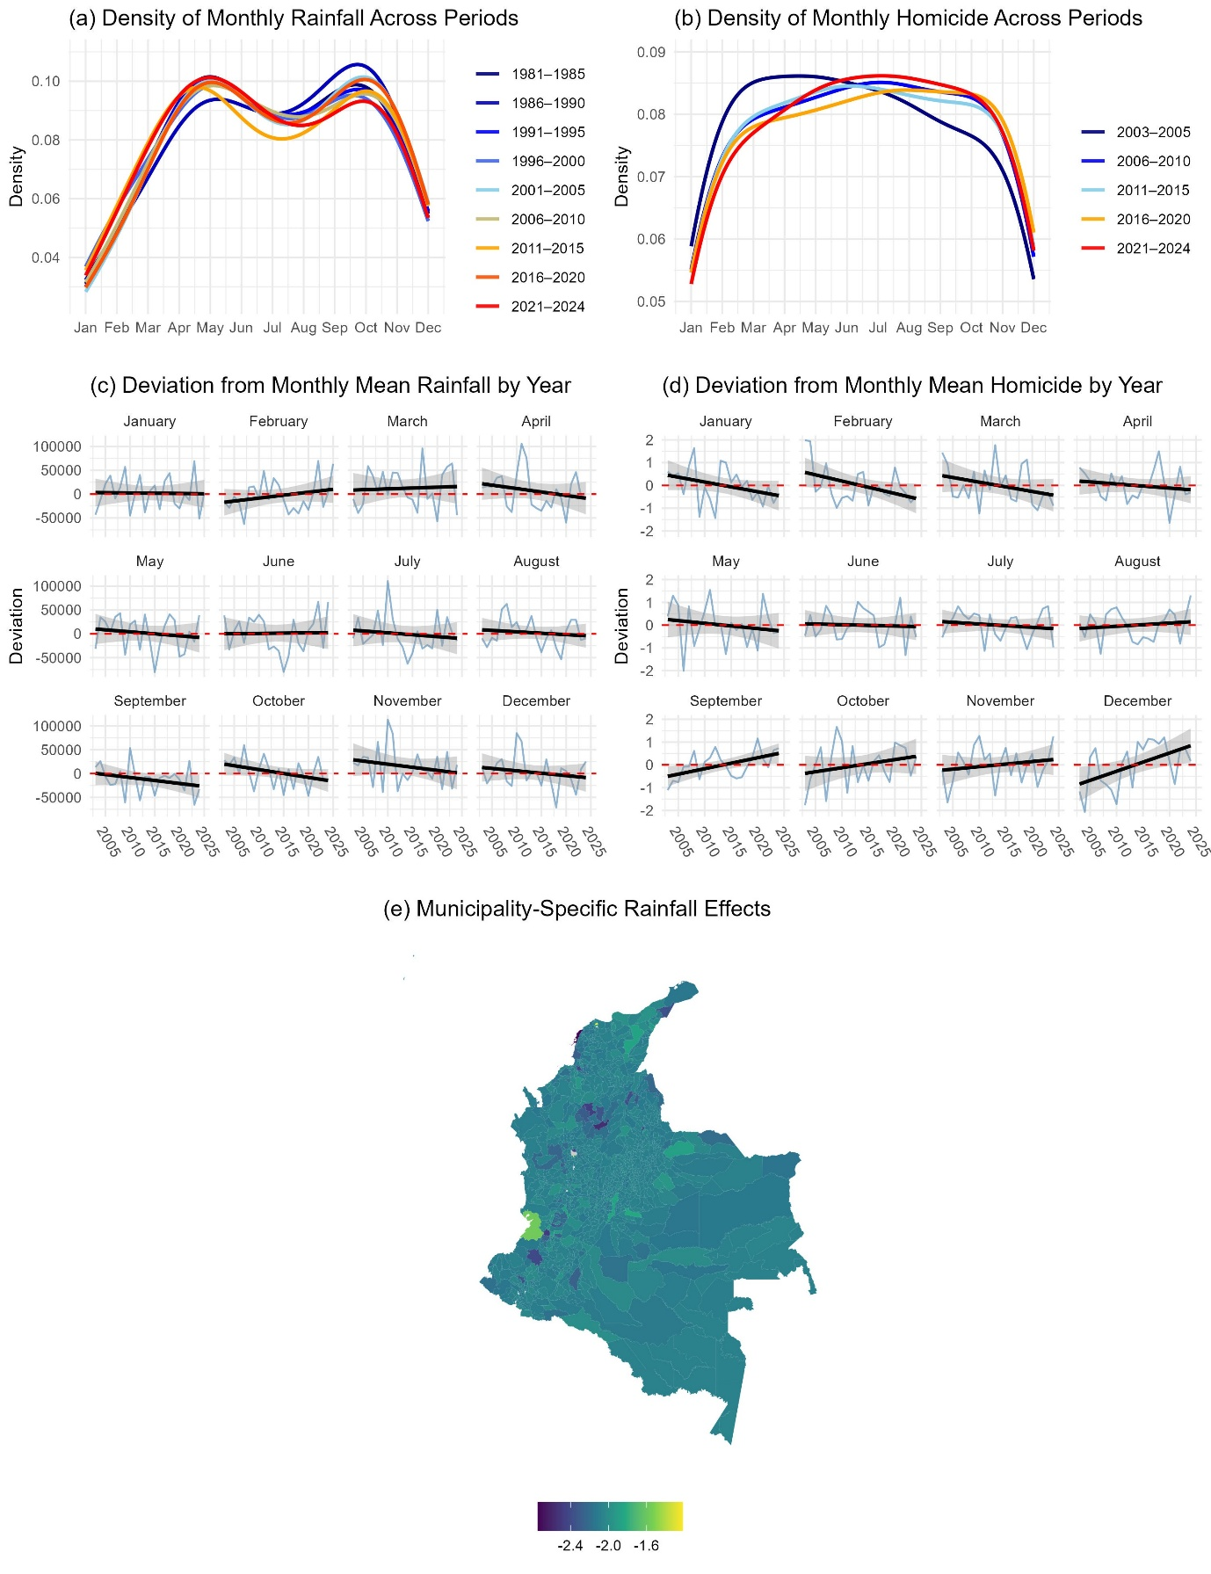
Figure 1 Long-Term Shifts in Rainfall Seasonality, Violence Seasonality, and Spatial Heterogeneity of Rainfall Effects in Colombia

3.2 Seasonal Changes in Rainfall and Homicide in Mexico
The visual inspection of shifts in seasonal rainfall patterns in Mexico is less pronounced than in the Colombian case. Monthly rainfall deviations show only small increases in December, January, and June, and slightly more noticeable declines in July and September (Figure 2a and 2c). In contrast, shifts in homicide seasonality are far more distinct: violence now falls well below historical levels between November and February, and rises markedly above historical levels between May and September (Figure 2b and 2d). We follow the same analytic strategy as in the Colombian analysis to formally assess the relationship between rainfall anomalies and violence.
We begin by evaluating whether rainfall anomalies correspond to national-level seasonal shifts in violence. A two-way fixed-effects panel regression with year and month fixed effects reveals a clear negative association between rainfall and homicide anomalies (β = –0.229; ±2 SE = –0.346 to –0.112), with all robustness checks closely replicating this result. At the national level, wetter-than-usual months tend to coincide with lower-than-usual homicide levels.
We next assess whether rainfall anomalies explain month-to-month variation in violence within states. A three-way fixed-effects model with state, year, and month fixed effects produces a small but statistically consistent negative effect (β = –0.028; ±2 SE = –0.050 to –0.006), and two robustness models yield virtually identical estimates. As in Colombia, this pattern likely reflects heterogeneity in subnational conditions: some states exhibit stronger negative rainfall-violence associations, while others show effects close to zero, resulting in a compressed near-zero average when pooled.
To explore this heterogeneity directly, we estimate a model with state-specific slopes (Figure 2e). These results reveal substantial cross-state variation in the strength—and, in a small number of cases, the direction—of the rainfall-violence relationship. Most states display negative slopes, consistent with the national pattern. However, several states in hot arid regions along the Pacific Coast and within the Chihuahuan Desert exhibit weakly positive slopes, suggesting that rainfall may temporarily increase mobility and outdoor routine activities in particularly dry climates.
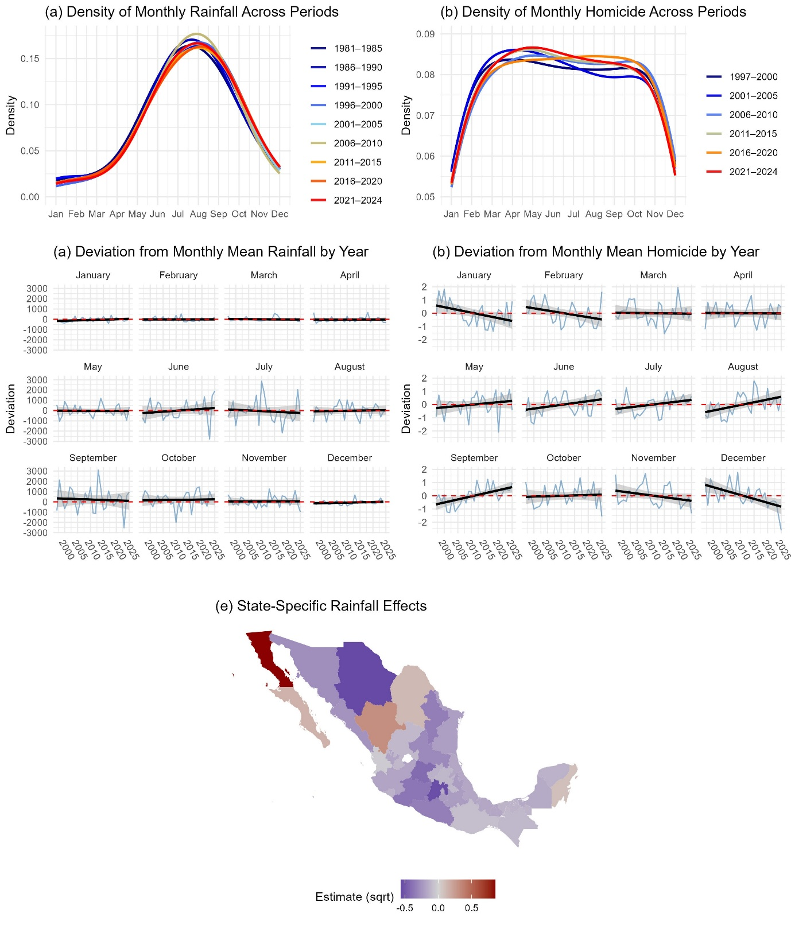
Figure 2 Long-Term Shifts in Rainfall Seasonality, Violence Seasonality, and Spatial Heterogeneity of Rainfall Effects in Mexico

3.3 Seasonal Changes in Rainfall and Street Violence in Gainesville, Florida
Figures 3a and 3c show that seasonal rainfall regimes have undergone substantial shifts since the early 20th century in Gainesville, FL. The beginning of the year is now drier than in previous decades, while rainfall between July and October has steadily increased. Patterns of violence have shifted as well: violence is now considerably above historical levels in May and June, and below historical levels in August and September (Figures 3b and 3d). We assess the relationship between rainfall and violence anomalies using fixed-effects and panel regression models.
The two-way fixed-effects panel model with year and month fixed effects indicates a negative but less precise association (β = –0.124; ±2 SE = –0.297 to 0.050). All robustness checks yield estimates of similar magnitude and direction. These models suggest a tendency for wetter-than-usual months to coincide with lower-than-usual violence, but caution is warranted, as the estimates are less precise than in the previous two case studies, potentially due to the more restricted length of the time series.

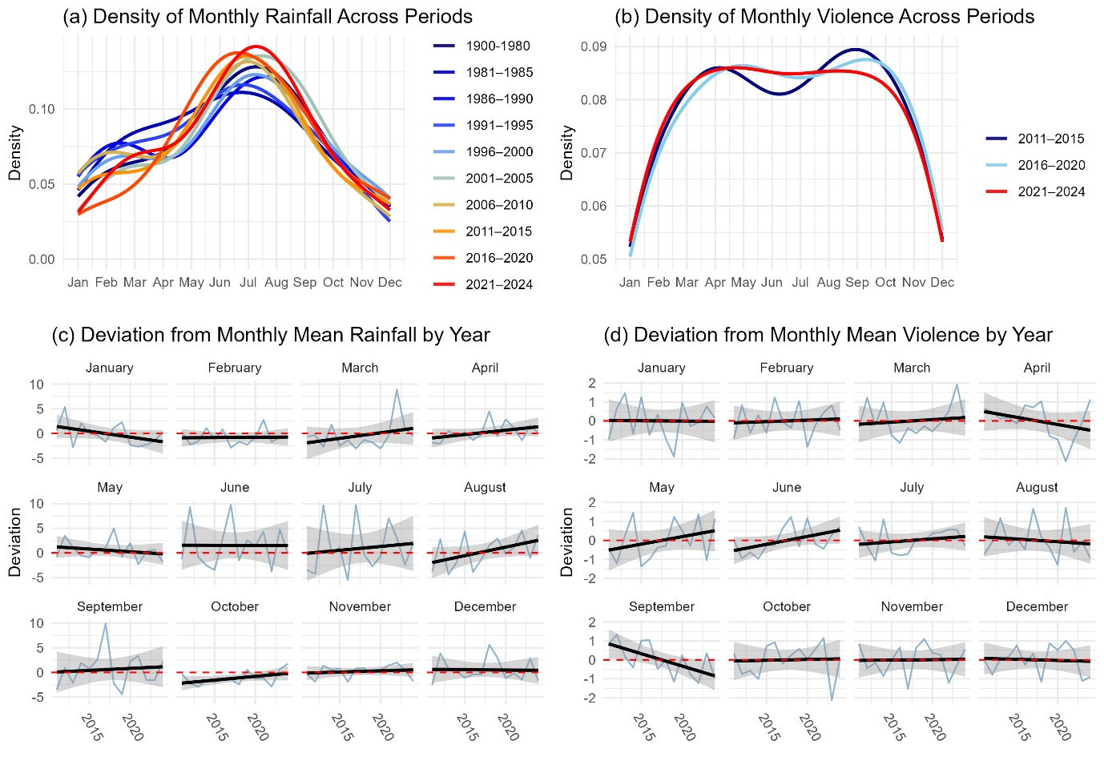
Figure 3 Long-Term Shifts in Rainfall Seasonality and Violence Seasonality in Gainesville, Florida

4 Discussion

Mexico opposite coefs: This aligns with theoretical accounts such as Agnew’s (2011) strain framework, which posits that relief from chronic environmental stressors (including drought) may reduce negative affect and increase social interaction.

References
Agnew, R. (2011). Dire forecast: A theoretical model of the impact of climate change on crime. Theoretical Criminology, 16(1), 21-42. https://doi.org/10.1177/1362480611416843
Almazroui, M., Islam, M. N., Saeed, F., Saeed, S., Ismail, M., Ehsan, M.A., ... & Barlow, M. (2021). Projected changes in temperature and precipitation over the United States, Central America, and the Caribbean in CMIP6 GCMs. Earth Systems and Environment, 5(1), 1-24. https://doi.org/10.1007/s41748-021-00199-5
Anderson C.A., & Anderson K.B. (1998). Temperature and Aggression: Paradox, Controversy, and a (Fairly) Clear Picture. In R.G. Geen & E.D. Donnerstein (Eds.), Human Aggression: Theories, Research, and Implications for Social Policy (pp. 247-298). Academic Press.
Anderson, C.A., Deuser, W.E., & DeNeve, K.M. (1995). Hot Temperatures, Hostile Affect, Hostile Cognition, and Arousal: Tests of a General Model of Affective Aggression. Personality and Social Psychology Bulletin, 21(5), 434-448. https://doi.org/10.1177/0146167295215002
Andresen, M.A., & Malleson, N. (2013). Crime Seasonality and its Variations across Space. Applied Geography, 43, 25-35. https://doi.org/10.1016/j.apgeog.2013.06.007
Baumer. E., & Wright, R. (1996). Crime Seasonality and Serious Scholarship: A Comment on Farrell and Pease. British Journal of Criminology, 36(4), 579-581. https://doi.org/10.1093/oxfordjournals.bjc.a014113
Bell, P.A., & Baron, R.A. (1976). Aggression and Heat: The Mediating Role of Negative Affect1. Journal of Applied Social Psychology, 6, 18-30. https://doi.org/10.1111/j.1559-1816.1976.tb01308.x
Breetzke, G.D., & Cohn, E.G. (2011). Seasonal Assault and Neighborhood Deprivation in South Africa: Some Preliminary Findings: Some Preliminary Findings. Environment and Behavior, 44(5), 641-667. https://doi.org/10.1177/0013916510397758
Cheatwood, D. (1995). The Effects of Weather on Homicide. Journal of Quantitative Criminology, 11, 51-70. https://doi.org/10.1007/BF02221300
Choi, H.M., Heo, S., Foo, D., Song, Y., Stewart, R., Son, J., & Bell, M.L. (2024). Temperature, Crime, and Violence: A Systematic Review and Meta-Analysis. Environmental Health Perspectives, 132(10), 106001. https://doi.org/10.1289/EHP14300
Cohen, L.E., & Felson, M. (1979). Social Change and Crime Rate Trends: A Routine Activity Approach. American Sociological Review, 44(4), 588-608. https://doi.org/10.2307/2094589
Cohn, E.G. (1990). Weather and Crime. British Journal of Criminology, 30(1), 51-64. https://doi.org/10.1093/oxfordjournals.bjc.a047980
Corcoran, J., & Zahnow, R. (2021). The Effect of Weather on Assault. Environment and Behavior, 54(2), 300-326. https://doi.org/10.1177/00139165211014629
Dore, M.H.I. (2005). Climate Change and Changes in Global Precipitation Patterns: What Do We Know? Environment International, 31(8), 1167-1181. https://doi.org/10.1016/j.envint.2005.03.004
Esteban-Cantillo, O.J., Clerici, N., Avila-Diaz, A., & Quesada, B. (2024). Historical and future extreme climate events in highly vulnerable small Caribbean Islands. Climate Dynamics, 62(8), 7233-7250. https://doi.org/10.1007/s00382-024-07276-1
Gamble, D.W., & Curtis, S. (2008). Caribbean precipitation: review, model and prospect. Progress in Physical Geography: Earth and Environment, 32(3), 265-276. https://doi.org/10.1177/0309133308096027
Gamble, J.L., & Hess, J.J. (2012). Temperature and Violent Crime in Dallas, Texas: Relationships and Implications of Climate Change. The Western Journal of Emergency Medicine, 13(3), 239-246. https://doi.org/10.5811/westjem.2012.3.11746
Hipp, J.R., Curran, P.J., Bollen, K.A., & Bauer, D.J. (2004). Crimes of Opportunity or Crimes of Emotion? Testing Two Explanations of Seasonal Change in Crime. Social Forces, 82(4), 1333-1372. https://doi.org/10.1353/sof.2004.0074
Hodgkinson, T., & Vamvakaris, C. (2025). Back to School Days: Crime Seasonality in a Campus-Dominated Community. Journal of Criminal Justice, 98, 102388. https://doi.org/10.1016/j.jcrimjus.2025.102388
Karmalkar, A.V., Taylor, M.A., Campbell, J., Stephenson, T., New, M., Centella, A., ... & Charlery, J. (2013). A review of observed and projected changes in climate for the islands in the Caribbean. Atmósfera, 26(2), 283-309. https://doi.org/10.1016/S0187-6236(13)71076-2
Mares, D. (2013). Climate Change and Crime: Monthly Temperature and Precipitation Anomalies and Crime Rates in St. Louis, MO 1990–2009. Crime, Law and Social Change, 59, 185-208. https://doi.org/10.1007/s10611-013-9411-8
Mares, D.M., & Moffett, K.W. (2019). Climate Change and Crime Revisited: An Exploration of Monthly Temperature Anomalies and UCR Crime Data. Environment and Behavior, 51(5), 502-529. https://doi.org/10.1177/0013916518781197
Martinez, C., Goddard, L., Kushnir, Y., & Ting, M. (2019). Seasonal Climatology and Dynamical Mechanisms of Rainfall in the Caribbean. Climate Dynamics, 53(1), 825-846. https://doi.org/10.1007/s00382-019-04616-4
Martinez, C., Munoz, A. G., Goddard, L., Kushnir, Y., & Ting, M. (2022). Seasonal Prediction of the Caribbean Rainfall Cycle. Climate Services, 27, 100309. https://doi.org/10.1016/j.cliser.2022.100309
McDowall, D., Loftin, C., & Pate, M. (2012). Seasonal Cycles in Crime, and Their Variability. Journal of Quantitative Criminology, 28, 389-410. https://doi.org/10.1007/s10940-011-9145-7
Pascale, S., Carvalho, L.M., Adams, D.K., Castro, C.L., & Cavalcanti, I.F. (2019). Current and Future Variations of the Monsoons of the Americas in a Warming Climate. Current Climate Change Reports, 5(3), 125-144. https://doi.org/10.1007/s40641-019-00135-w
Quetelet, A. (1842). A Treatise on Man and the Development of His Faculties. William and Robert Chambers.
Reyer, C.P., Adams, S., Albrecht, T., Baarsch, F., Boit, A., Canales Trujillo, N., ... & Thonicke, K. (2017). Climate Change Impacts in Latin America and the Caribbean and Their Implications for Development. Regional Environmental Change, 17(6), 1601-1621. https://doi.org/10.1007/s10113-015-0854-6
Sommer, A.J., Lee, M. & Bind, M. C. (2018). Comparing Apples to Apples: An Environmental Criminology Analysis of the Effects of Heat and Rain on Violent Crimes in Boston. Palgrave Communications, 4, 138. https://doi.org/10.1057/s41599-018-0188-3
Wesselbaum, D. (2022). Violent Crimes and Homicide in New York City: The Role of Weather and Pollution. Journal of Forensic and Legal Medicine, 91, 102430. https://doi.org/10.1016/j.jflm.2022.102430
Wright, N.A., & Stewart, A. M. (2025). The Impact of Weather Shocks on Violent and Property Crimes in Jamaica. The World Bank Economic Review, 39(1), 85-103. https://doi.org/10.1093/wber/lhae016
Wu, C.Y.H., Lee, H.F., & Liu, H. (2019). Effect of Temperature and Precipitation Change on Crime in the Metropolitan Area in Virginia, USA. Asian Geographer, 37(1), 17-31. https://doi.org/10.1080/10225706.2019.1678046
Xu, R., Xiong, X., Abramson, M.J., Li, S., & Guo, Y. (2020). Ambient Temperature and Intentional Homicide: A Multi-City Case-Crossover Study in the US. Environment International, 143, 105992. https://doi.org/10.1016/j.envint.2020.105992
Yu, C.H., Mu, J.E., Ding, J., & McCarl, B.A. (2017). Relationships Between Typhoons, Climate and Crime Rates in Taiwan. Natural Hazards, 89(2), 871-897. https://doi.org/10.1007/s11069-017-2998-9

https://www.datos.gov.co/Seguridad-y-Defensa/HOMICIDIO/m8fd-ahd9/about_data
https://data.humdata.org/dataset/col-rainfall-subnational
https://www.gob.mx/sesnsp/acciones-y-programas/datos-abiertos-de-incidencia-delictiva
https://data.humdata.org/dataset/mex-rainfall-subnational
https://data.cityofgainesville.org/Public-Safety/Crime-Responses/gvua-xt9q/about_data
https://climatecenter.fsu.edu/products-services/data/precipitation/gainesville
One-way fixed-effects panel regression with fixed effects for year: β = –0.176; ±2 SE = –0.321 to –0.031. GLS regression with AR(1): β = –0.123; ±2 SE = –0.243 to –0.002. GLS with AR(2): β = –0.119; ±2 SE = –0.239 to 0.001. GLS with AR(3): β = –0.128; ±2 SE = –0.247 to -0.008.
One-way fixed-effects panel regression with fixed effects for year and dummy controls for municipality: β = –0.003; ±2 SE = –0.007 to 0.001. One-way fixed-effects panel regression with fixed effects for municipality: β = –0.003; ±2 SE = –0.007 to 0.001.
One-way fixed-effects panel regression with fixed effects for year: β = –0.228; ±2 SE = –0.343 to –0.113. GLS regression with AR(1): β = –0.177; ±2 SE = –0.278 to –0.077. GLS with AR(2): β = –0.178; ±2 SE = –0.278 to –0.078. GLS with AR(3): β = –0.175; ±2 SE = –0.275 to -0.075.
One-way fixed-effects panel regression with fixed effects for year and dummy controls for municipality: β = –0.028; ±2 SE = –0.050 to –0.006. One-way fixed-effects panel regression with fixed effects for municipality: β = –0.028; ±2 SE = –0.050 to –0.007.
One-way fixed-effects panel regression with fixed effects for year: β = –0.124; ±2 SE = –0.291 to 0.044. GLS regression with AR(1): β = –0.108; ±2 SE = –0.263 to 0.047. GLS with AR(2): β = –0.108; ±2 SE = –0.263 to 0.047. GLS with AR(3): β = –0.106; ±2 SE = –0.262 to 0.049.

